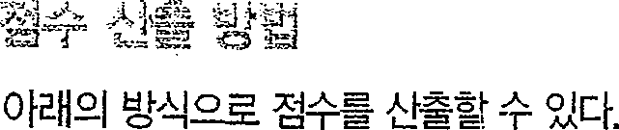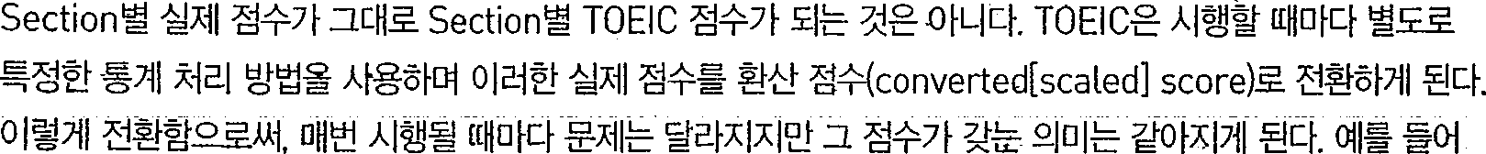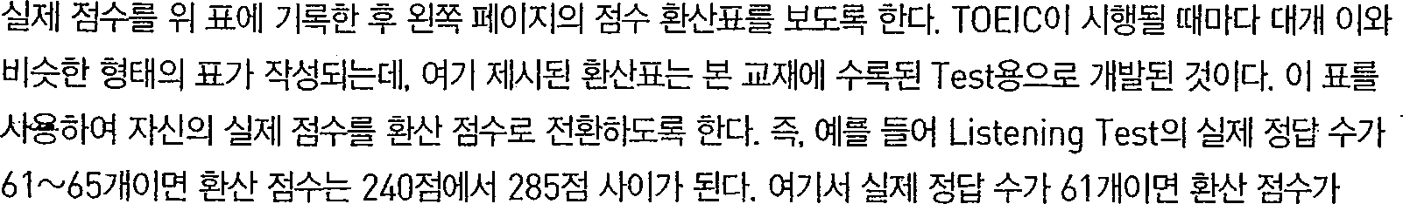



LISTENING READING



240’,j0)x>. 55 jo{ * ’%-rT1285% °% %0)o ’ 0(L) , g i ° l Tesi%o# 0) *,j



READING TEST

In the Reading test, you will read a variety of texts and answer *several* different types of reading comprehension questions. The entire Reading test will last 75 minutes. There are three parts, and directions are given for each part. You *are* encouraged to answer as many questions as possible within the time allowed.

You must mark your answers on the separate answer sheet. Do not write your answers in your test book.

PART 5

Directions: A word or phrase is missing in each of the sentences below. Four answer choices are given below each sentence. Select the best answer to complete the sentence. Then mark the letter (A), (B), (C), or (D) on your answer sheet.

|  |  |  |  |
| --- | --- | --- | --- |
|  | *Work Power* magazine is a new trade ------- | 165. | Ms. Rodriguez will speak about a banking |
| for human resource professionals. |  | conference she in Lisbon last month. |
| (A) publication |  | (A) attends |
| (B) publishers |  | (B) attended |
| (C) publish |  | (C) will attend |
| (D) is publishing |  | (D) attend |
| 102. | Ms. Murata requests that this month's sales | 106. | -- the success of his restaurant, chef |
|  | totals be submitted the end of the day. |  | Sook Yong wrote a best-selling cookbook. |
|  | 1. within 2. if 3. that |  | 1. Because 2. When 3. After |
|  | (D) by |  | (D) Already |
| 103. | A midsize design , Gilwood Interiors | 107. | The director of the Yeon Park Clinic will |
|  | specializes in residential spaces. |  | deliver a speech tonight’s benefit |
|  | (A) firm |  | dinner. |
|  | 1. program 2. piece |  | 1. except 2. before |
|  | (D) industry |  | (C) as |
| 104. | The board of directors thanked Juliana |  | (D) onto |
|  | Thorne for efforts in organizing the  shareholders’‘meeting. | 108. | The staff of the Meng Hotel will do -------  they can to make your stay as enjoyable as |

1. her



1. she
2. hers

# possible. ,

fr.) some

1. whatever
2. above

# each

18

Thank you for using [www.freepdfconvert.com](http://www.freepdfconvert.com/) service!

Only two pages are converted. Please Sign Up to convert all pages. <https://www.freepdfconvert.com/membership>